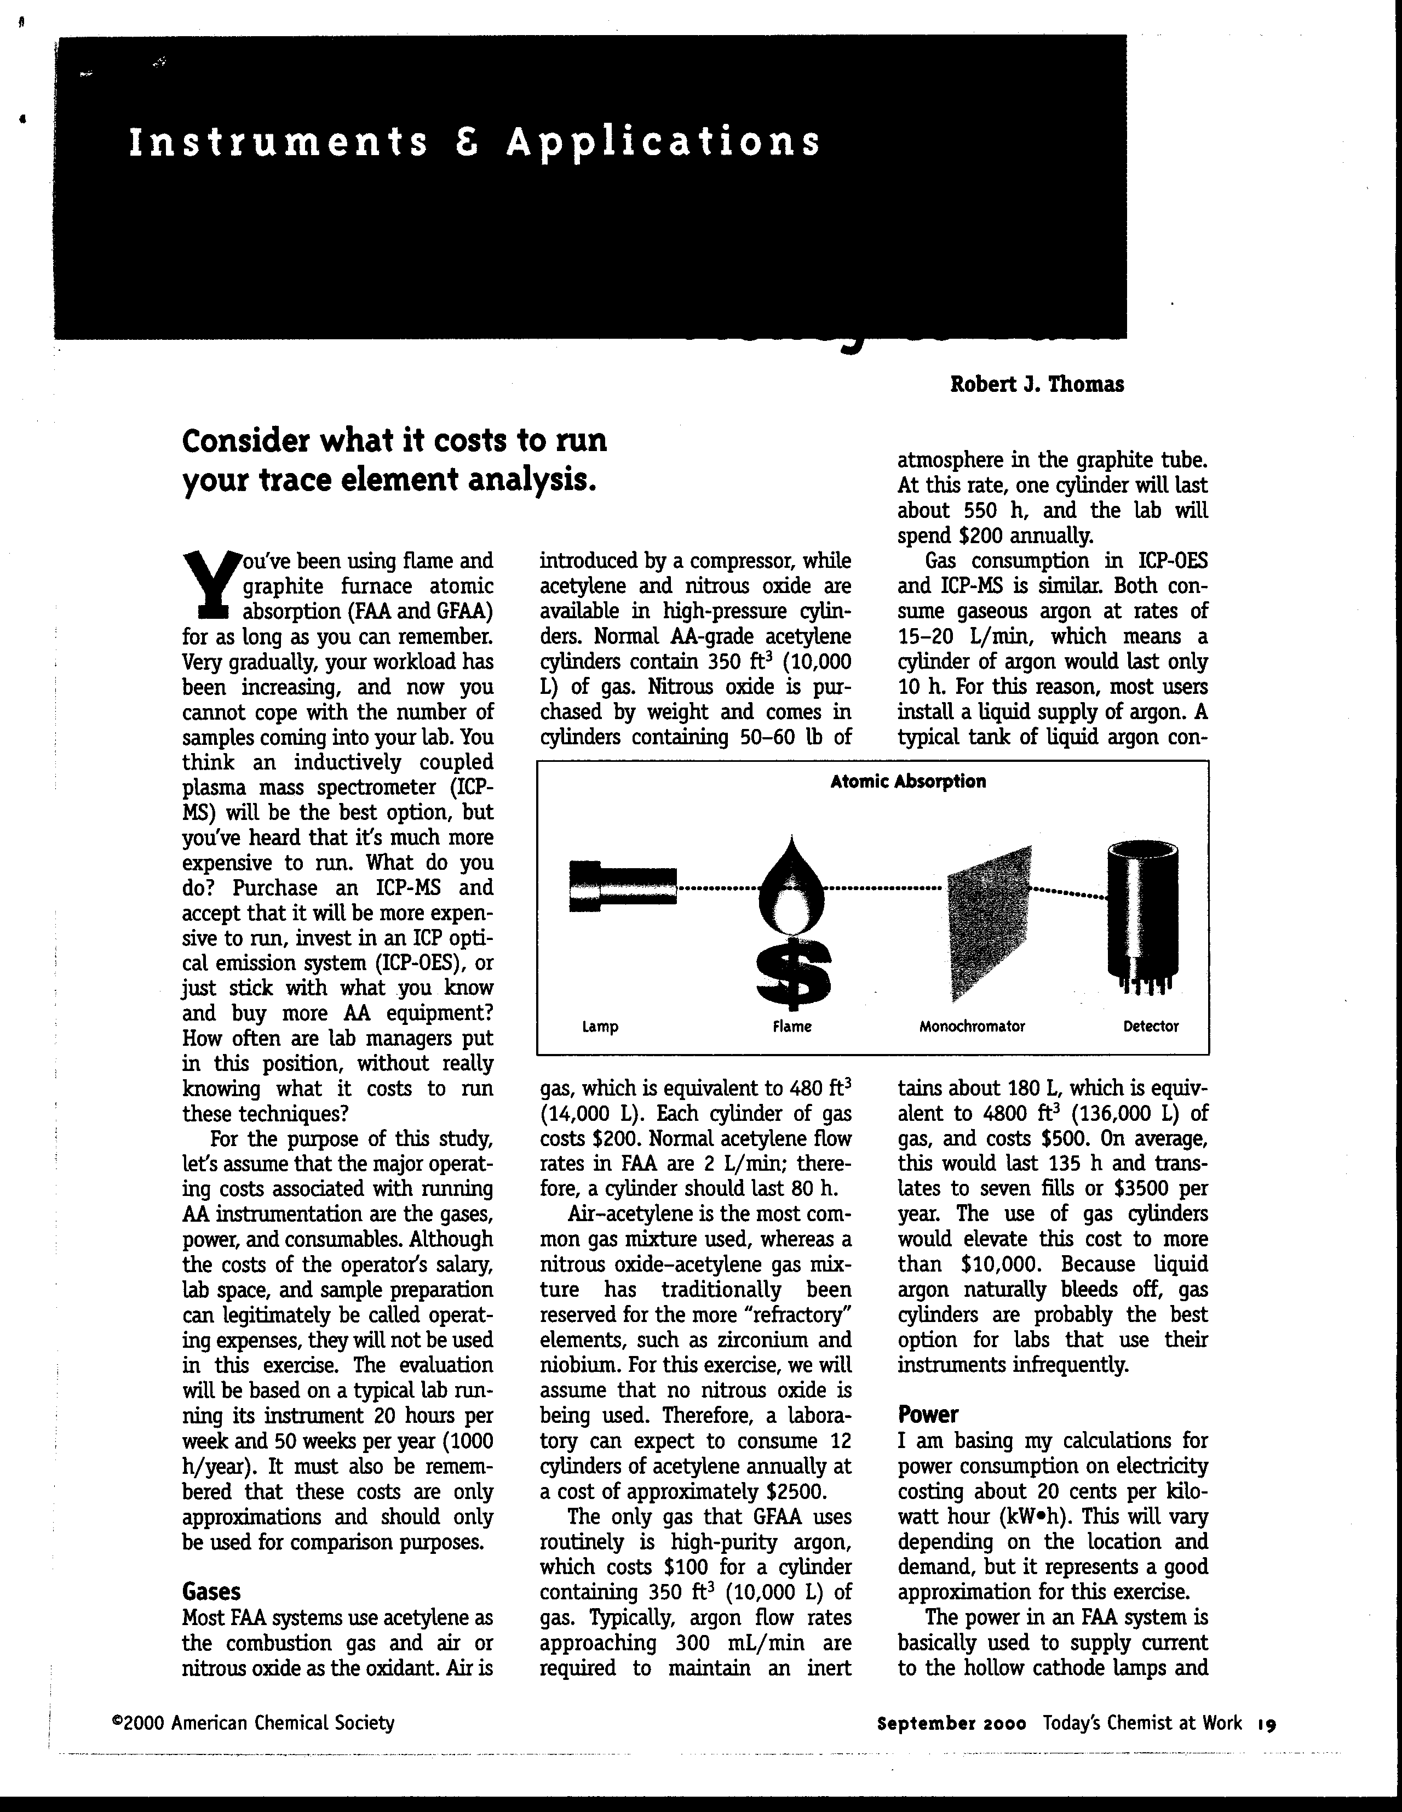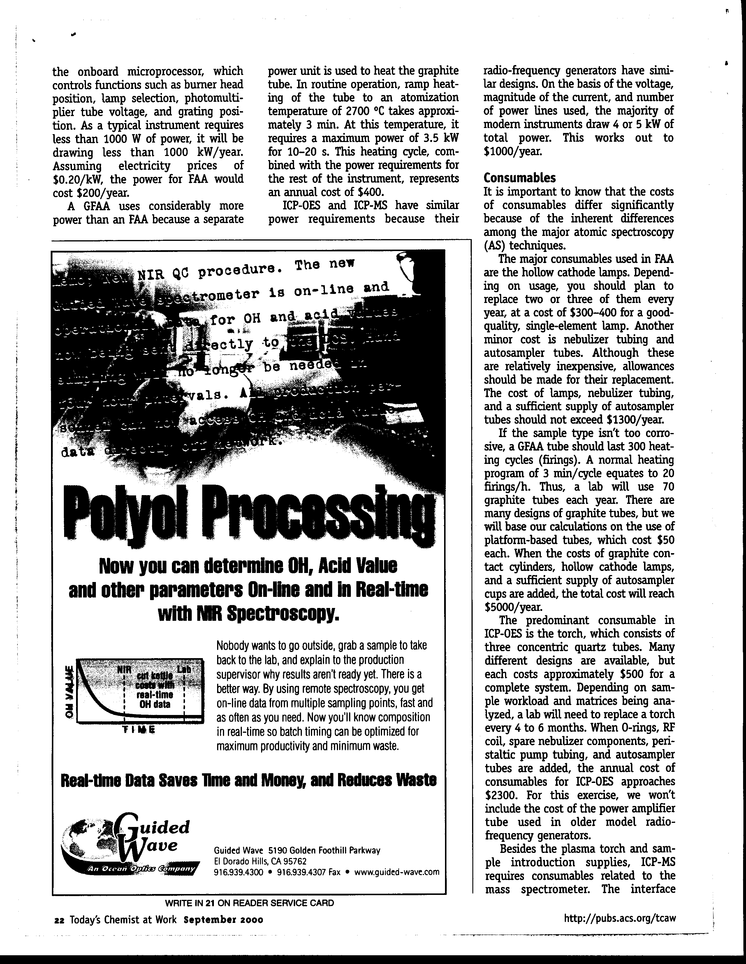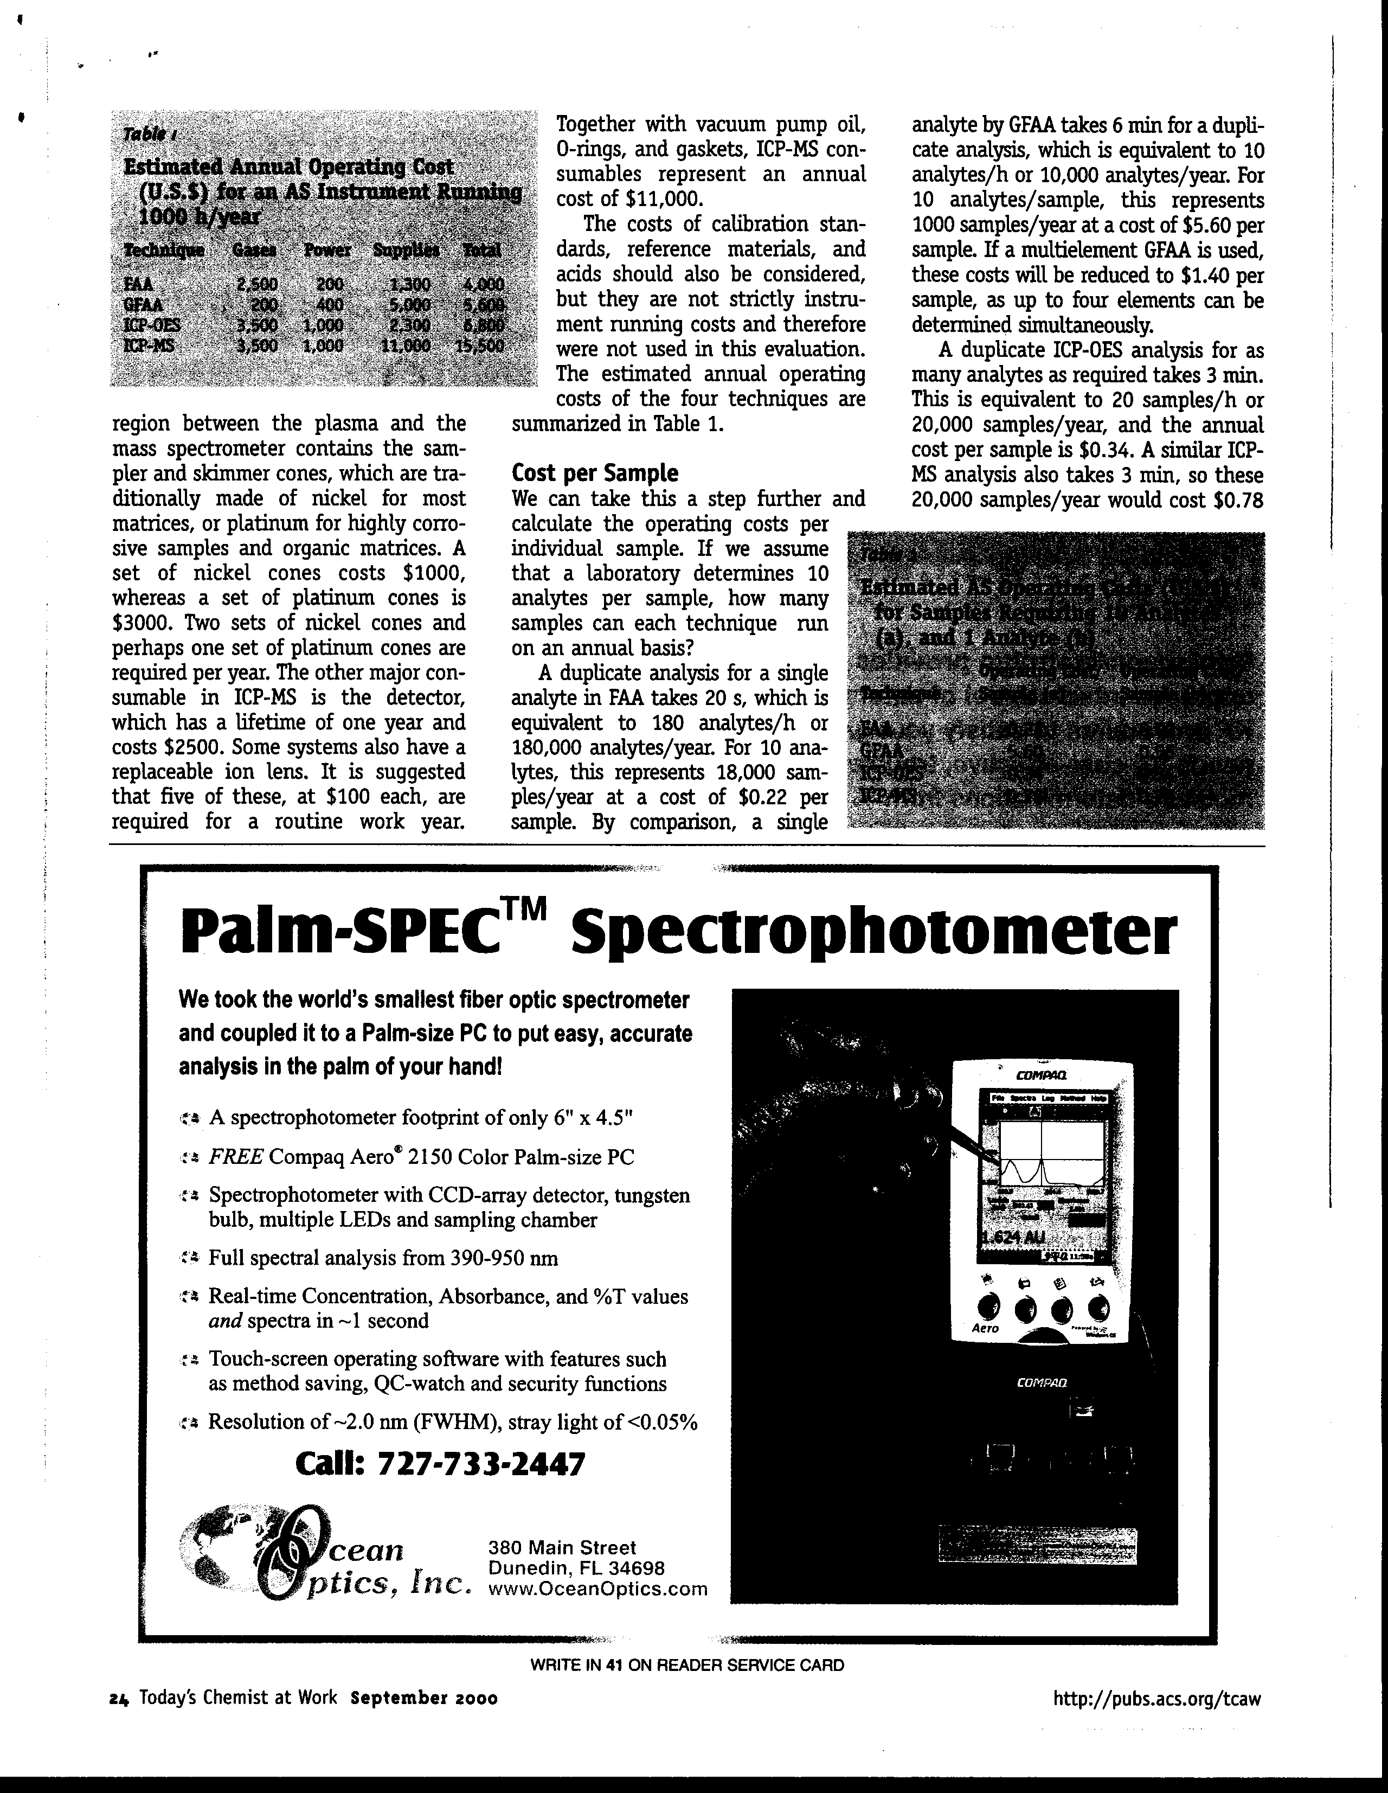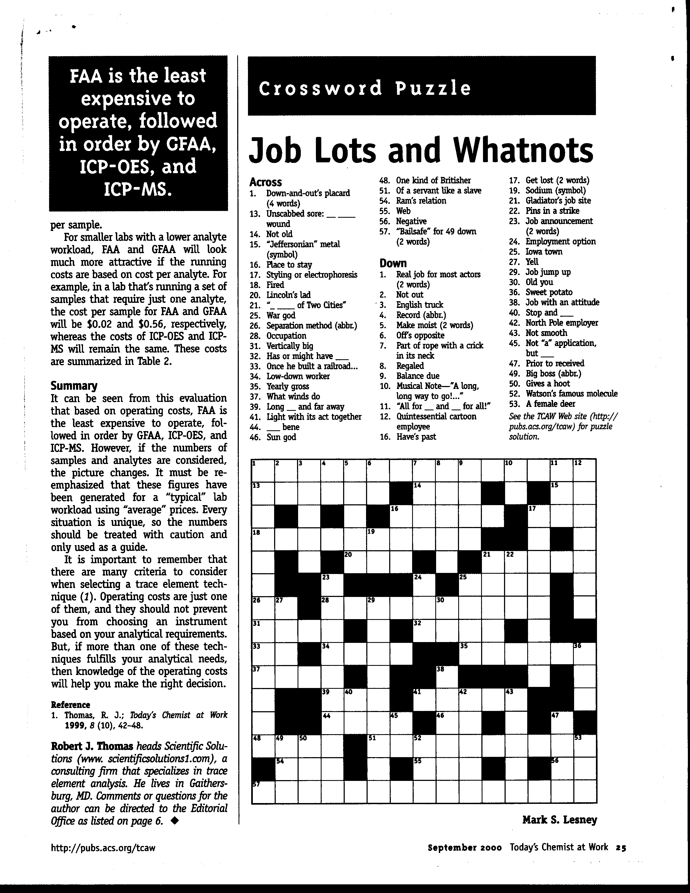

Money to Burn

Click here to view Table 1
Click here to view Table 2

Technique | Gases | Power | Supplies | Total
FAA | 2,500 | 200 | 1,300 | 4,000
GFAA | 200 | 400 | 5,000 | 5,600
ICP-OES | 3,500 | 1,000 | 2,300 | 6,800
ICP-MS | 3,500 | 1,000 | 11,000 | 15,500

Table I: Estimated annual operating cost (US$) for an AS instrument running 1000 hours/year

Technique | Operating Cost/Sample (a) | Operating Cost/Sample (b)
FAA | 0.22 | 0.02
GFAA | 5.60 | 0.56
ICP-OES | 0.34 | 0.34
ICP-MS | 0.78 | 0.78

Table 2: Estimated AS operating costs for samples requiring (a) ten analytes; (b) one analyte.

